Breakout SIM7020 User Manual

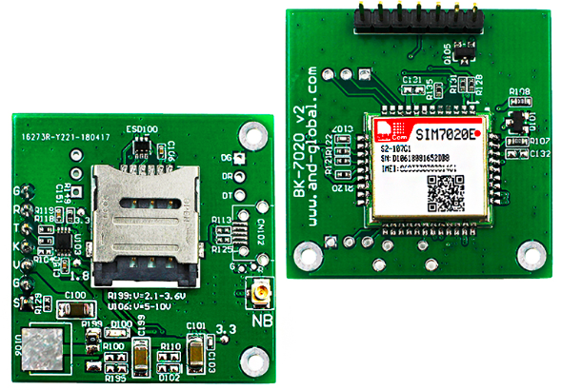

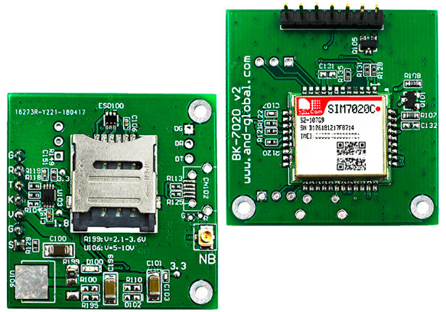

1. Preparation:
Board | BK-SIM7020
Serial tool | sscom32E.exe

2. Overview

2.1 Module feature
- Multi-Band NB-IoT module solution in a SMT type which is compatible with SIM800C package.
- Control Via AT Command, Rich interfaces including UART, GPIO etc
- Supply voltage range:2.1v~3.6v, Typ:3.3V
- Dimension: 17.6x15.7x2.3mm
- Operation temperature:-40℃ to +85 ℃
- PSM mode Consumption : 5 uA

2.2 BOARD overview
J100
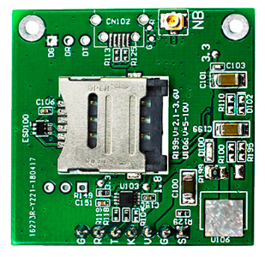
CN100
TP105
TP100
CN101
D10006
TP100

CN100 | Micro SIM card socket
CN101 | 7pin 2.54mm header interface
D100 | NET LIGHT indicator(Green)
J100 | NB-IoT ANT
TP105 | 2.1-3.6V
TP101 | 3.3V
TP100 | 1.8V
2.3 PCBA dimension: 37*37mm.
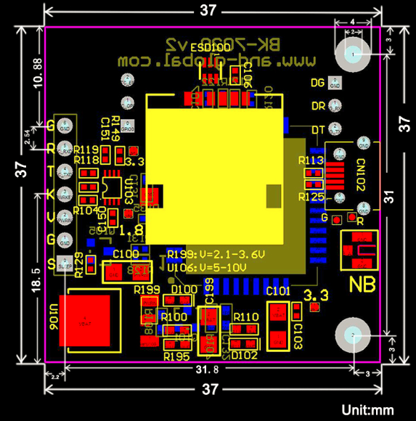
3. Pin definition
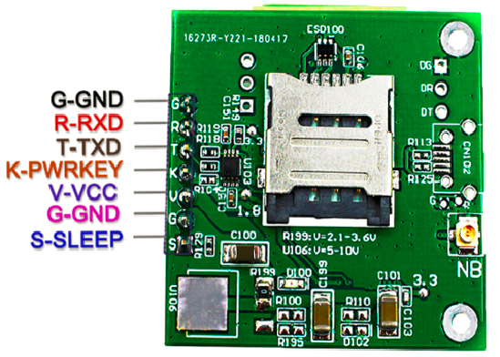
Note: VCC range is from 2.1V to 3.6V, 3.3V is recommended. Over-voltage will damage the module permanently.
TXD /RXD are 3.3V TTL level which can be directly connected with 3.3V MCU.
3.1 Pin definition of 6pin connector
Pin name | Pin number | Mark on PCB | Description | Comment
SLEEP | 0 | S | control module wakeup from sleep mode | Connect with DTR via Q105
GND | 1,6 | G | GND
VCC | 2 | V | Power input for sim7020 module | 2.1V-3.6V
PWRKEY | 3 | K | Power ON/OFF
TXD | 4 | T | Transmit Data | 3.3V TTL Series data Output
RXD | 5 | R | Receives Data | 3.3V TTL Series data Input

3.2 How to use TXD and RXD (Default baud rate is 115200bps)
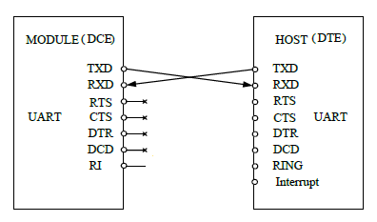

4. How to test the BK-SIM7020 by AT command via UART
4.1 Installing NB-IoT antenna, SIM card for BK-SIM7020 Board.(Note: Please use NB-IoT card, not normal Mobile phone card.)
4.2 Feed power supply to VCC pin. (Note: VCC range is from 2.1V to 3.6V. 3.3V is recommended.)
4.3 Short PWRKEY pin to GND to Power on sim7020 module. GREEN LED will be on, Blink quickly shows un-registration network, Blink slowly shows registration successful. (Note: Should confirm whether correct NB-IoT SIM card is inserted)
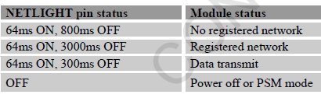
4.4 Open serial software  and choose right serial number, Baud rate as below, please keep “SendNew” selected:
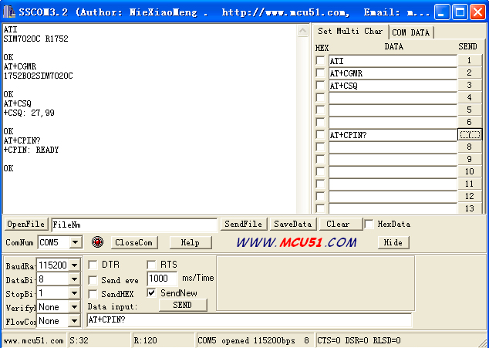

5.Package list：
Name | Qty | Unit
BK-SIM7020 | 1 | Pcs

